SOCIAL ENTREPRENEURSHIP
Module 7 – Materials for participants



Erasmus + Joint Qualifications in vocational education and training:
Development of managerial and entrepreneurial skills of young eco-farmers via joint VET curricula, enhanced qualification profile, assessment standard and sustainable cooperation synergies
ECOFAR project

MATERIALS – MODULE 7
SOCIAL ENTREPRENEURSHIP
Activity | WP 5
Title | Development of a joint qualification curriculum for the acquisition and further promotion of managerial and entrepreneurial competences in young entrepreneurs
Status | Final document
Dissemination of results | Limited
Publication Date | March 2020
Authors | CPI – Center RS za poklicno izobraževanje Slovenija (mag. Majda Gartner) / Institute of the Republic of Slovenia for Vocational Education and Training
Co-authors | Project partner P4 – University of Maribor, Slovenia

TABLE OF CONTENTS:
ABOUT SOCIAL ENTREPRENEURSHIP 1
1. SOCIAL ENTREPRENURSHIP, SOCIAL ENTERPRISE AND SOCIAL ECONOMY 1
1.1. What is social entrepreneurship? 1
1.2. A comparison between social entrepreneurship and traditional (market, commercial) entrepreneurship 3
1.3. Key principles and requirements in social entrepreneurship 4
1.4. Who is a social entrepreneur and what are the key characteristics for success? 5
2. LEGAL AND OTHER REGULATIONS FOR SOCIAL ENTREPRENURSHIP IN SLOVENIA 7
2.1. Social Entrepreneurship Act 7
2.2. Social Economy Development Strategy 8
2.3. Analysis of the situation in the field of social economy in Slovenia 8
3. ESTABLISHING A SOCIAL ENTERPRISE 10
3.1. The status of a social enterprise 10
3.2. When to embark on social entrepreneurship? 10
3.3. Phases of establishing a social enterprise 11
3.4. Values, mission, vision 12
3.5. How to come up with new ideas for social entrepreneurship? 12
3.6. Sustainability and development 13
4. SOCIAL ENTREPRENURSHIP IN ECOLOGICAL/ORGANIC FARMING 13
4.1. Types of social enterprises – how to choose the suitable type of company in the field of ecological/organic farming 13
5. THE ROLE OF STAKEHOLDERS AND NETWORKING IN THE SUCCESS OF A SOCIAL ENTERPRISE 14
5.1. Who are the stakeholders? 14
5.2. Networking 16
6. LEAN BUSINESS PLAN 17
6.1. About the lean business plan 17
7. Questions for knowledge assessment 18
8. Interesting additional sources 21

ABOUT SOCIAL ENTREPRENEURSHIP

SOCIAL ENTREPRENURSHIP, SOCIAL ENTERPRISE AND SOCIAL ECONOMY

What is social entrepreneurship?
Social entrepreneurship is a form of entrepreneurship with a pronounced sense of responsibility for the society and people. Social entrepreneurship is characterized by the fact that the motives for business are directed towards resolving social, economic, environmental, and other issues in the society in an innovative way. The basic purpose of this alternative form of entrepreneurship is market functioning while taking into account other principles of social entrepreneurship, whereby the no-profit principle, equality of members, and stakeholder participation in management are those principles that most clearly differentiate social enterprises from traditional economic operators. The no-profit principle stipulates that the purpose of establishing a social enterprise is not solely to generate profit, and that the assets and excess of income over expenditure (profit generated) are invested back into the activity of the social enterprise, so its division is not permissible. The principle of equality of members stipulates that individual founders or owners do not have a dominant influence in decision making; decisions are made by all members following the principle ‘one member – one vote’, regardless of the share of invested capital. The principle of stakeholder participation in management requires that other stakeholders be involved in decision-making.
By legal definition, social entrepreneurship (Social Entrepreneurship Act, ZSocP-A) refers to "the permanent pursuit of an entrepreneurial activity through the production and sale of products or the provision of services in a market where profit generation is not the main goal of entrepreneurial activity, but rather the achievement of social impact."
Social entrepreneurship can be practiced in all areas of economic and non-economic activities, with the practice showing that social enterprises are a kind of "hybrid" between the public and the private, and usually engage in activities that the public and private sectors cannot or do not want to undertake to a sufficient extent for various reasons, such as lack of public funds or lack of profitability. Consequently, the implementation of social entrepreneurship is not limited only to the integration of vulnerable groups in the labour market and the provision of social services of general interest, but also opens up wider opportunities for generating social innovation. The crucial point is that it provides a (broader) social impact.
By legal definition, a social enterprise (ZSocP-A) is a “non-profit legal entity that acquires the status of a social enterprise and can be an association, institute, institution, company, cooperative, European cooperative or other legal person governed by private law, which is not established solely for the purpose of creating profit, which does not share its assets, and which does not share the generated excess of income over expenditure." The status of social enterprise can be acquired by any non-profit legal entity, which undertakes to act according to the eleven principles of social entrepreneurship: autonomous initiative, non-profitability, market orientation, involvement of volunteer work, equality of members, participation of stakeholders in management, transparent business and socially useful functioning.
Social entrepreneurship is part of a broader concept of social economy, which is legally defined (ZSocP-A) as “an economy consisting of social enterprises, cooperatives, disability enterprises, employment centres, non-governmental organizations (associations, institutes, institutions or foundations), which are not established solely for the purpose of creating profit, act for the benefit of their members, users or the wider community and produce marketable or non-marketable products and services." However, unlike social enterprises, they can share profits, they can only pursue non-economic activities (the principle of market orientation does not apply), the owners / founders can have a dominant influence in decision-making (the principle of equality of members does not apply), and other stakeholders do not have to be involved in decision-making. Other stakeholders (the principle of stakeholder participation in management does not apply).
(source: http://www.mgrt.gov.si/si/delovna_podrocja/socialno_podjetnistvo/)
In the Global Entrepreneurship Monitor 2010, Dr. Rebernik defined social entrepreneurship as a spectrum of economic activities that are neither part of the public nor the private sector; as a rule, they are owned by stakeholders whose primary purpose is not profit generation. Social entrepreneurship encourages collaboration, joint ventures, volunteering; it promotes social solidarity, and above all, looks for innovative business solutions for perceived social, environmental, economic and other issues. By creating additional jobs where the private sector has no interest due to low profits, and by employing vulnerable groups in the labour market (the long-term unemployed, the disabled, the elderly unemployed, etc.), it ensures increased social well-being and gross national happiness.
(source: http://www.gemslovenia.spletnestrani.com/gem-porocila/)
However, Corporate Social Responsibility companies are not necessarily social enterprises. The main purpose of a social enterprise is to create social change, while socially responsible companies only react to social change with a part of their entrepreneurial activity within the so-called "quality-of-life management", by taking into account broader social interests, while generating profit remains the primary purpose of the business.
Example: TOMS is a shoe-manufacturing social enterprise. For each pair sold, TOMS donates a pair of shoes to underprivileged children. In addition, TOMS spends all generated profits on company growth and job creation in developing countries. On the other hand, Levi’s, a manufacturer of denim products, has shown social responsibility by minimizing water consumption in their production. They have shared innovations in reducing water consumption in the production with other manufacturers as well, which has a major environmental impact. While TOMS is a company created to “put shoes on poor children’s feet” and thus a generator of social change, the purpose of Levi’s is still to sell denim and create profit, but their production method has been a response to an existing environmental issue.
(source: https://socialbusinessearth.org/our-social-business-projects/)
You can watch a short video on social entrepreneurship here:
https://www.youtube.com/watch?v=9_g5RqwW51I&list=PL6HxSyThhJKcEyEqOTRRVuj1QoqaYY7xI

A comparison between social entrepreneurship and traditional (market, commercial) entrepreneurship

 | Social enterprise | Traditional/commercial enterprise
Motive | Mission/vision | Profit
Idea | Identifies market in the field of social issues | Identifies market/niche market
Purpose | Growth of social capital and social change | Company growth and profit generation
Profit | Profit goes to social change growth | Generation of profit for the entrepreneur/owner

Find out more about the comparison in this short film:
http://www.socialenterprisebsr.net/2019/01/what-is-the-difference-social-entrepreneurship-vs-traditional-entrepreneurship/)
(source: http://www.socialenterprisebsr.net/2019/01/what-is-the-difference-social-entrepreneurship-vs-traditional-entrepreneurship/)

Key principles and requirements in social entrepreneurship
Social enterprises may be established by non-profit legal entities that were established and are operating according to the following principles and requirements that demonstrate their publicly beneficial and social character (Social Entrepreneurship Act, Article 4):
- they are established on the basis of a voluntary decision of the founders (autonomous initiative);
- the purpose of establishing is not profit exclusively (non profit-making purpose);
- they are established predominantly for the purpose of pursuing social entrepreneurship or other activities on a permanent basis with a view to employing the most vulnerable groups of people in the labour market, thereby achieving public interest (exercise of activities in the public interest);
- their members act voluntarily (voluntary action);
- they are autonomous in management (independence);
- by producing and selling products or providing services on the market, they mainly operate in accordance with market laws (market orientation);
- as a rule, they involve volunteer work (involvement of volunteer work);
- individual founders or owners do not have a dominant influence in decision-making; decisions are made by all members following the principle of one member - one vote, regardless of the share of invested capital (equality of membership);
- they involve stakeholders in decision-making (stakeholder involvement in management);
- wealth, profit and excess of income over expenditure are used for social entrepreneurship purposes and other non-profit purposes, while the sharing of profit or excess of income is not permissible or is restricted under the Social Entrepreneurship Act (non-profit activity);
- ensure transparency of financial operations and internal control over material and financial operations (transparency of operations);
- act permanently for the benefit of their members, users and the wider community (activity in the public interest).

In order to fulfill the conditions, a social enterprise must incorporate three dimensions:
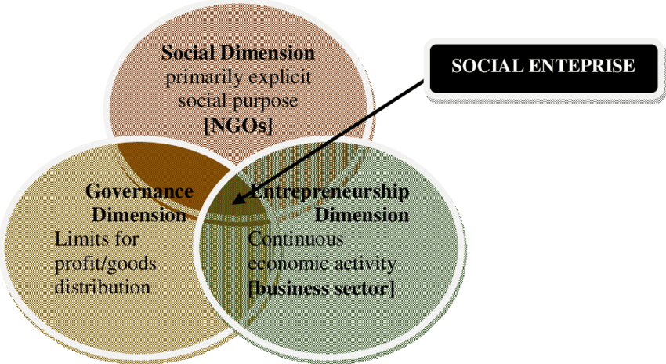

(source: https://www.researchgate.net/figure/Dimensions-of-social-enterprises-Wilkinson-et-al-2014_fig1_304625254 )

Who is a social entrepreneur and what are the key characteristics for success?
Social entrepreneurs are the reformers and revolutionaries of contemporary society. They are making drastic changes in the way they tackle challenges/problems in the social sector. With their visions and solutions, they eliminate the root causes of social problems and provide long-term solutions. They try to involve people who need help as much as possible in the realization of their ideas, thus helping them to improve their lives on their own. A social entrepreneur works with a clear social mission. Their main goal is to "change the world for the better". They are willing to take the risk of pursuing an idea, whereby a positive change in the environment and personal satisfaction in helping to create a better world is more important than profit.
Social entrepreneurs strive to create long-term social improvements, and are always looking for new ways to change and provide innovative solutions to social problems. They make use of all kinds of resources at their disposal, from purely charitable ones such as donations or volunteer work, to business resources such as joint ventures with other businesses, thus seeking to ensure a continuous and effective functioning of their organizations. They provide social improvements for users and communities while also trying to provide attractive social or financial returns for investors.
Among the key personality traits of a successful social entrepreneur are the following:
- Innovation / creativity – the ability of the "extraordinary" to find different solutions and to achieve changes that others do not believe to be possible is a fundamental driver of a social entrepreneur / enterprise. A successful entrepreneur is always thinking and innovating "outside the box"
- Self-confidence – confident people follow their intuition and realize things that seem impossible to others, who often do not even try. This is also a key factor of success in social entrepreneurship as well. Being a social entrepreneur means consciously creating / causing change. A social entrepreneur has to remain confident even in situations where other partners do not see the possibility of realizing ideas / projects.
- Persistence – is probably one of the greatest qualities of a successful social entrepreneur. "Never give up" is a key principle of any business, but most of all it holds true for social entrepreneurs, who are trying to change the world. Being a social entrepreneur means doing things the hard way, and trying harder than others do.
- Leadership – the ability to persuade others to work together and inspire them to change is essential in trying to achieve a wider social impact. Being a social entrepreneur means guiding the implementation of an innovative solution, starting with the engagement of the wider community in the idea, in order to bring about positive changes and ensure their sustainability.
- Team spirit / solidarity: working with different stakeholders is essential for the realization of any social entrepreneurship project, which is why fostering a team spirit is necessary and important. Being a social entrepreneur means working together and connecting different ideas to create solutions that meet most of the needs of all stakeholders involved.
- Flexibility – the ability to adapt to the rapidly changing world around us and find solutions where others only see problems is a key characteristic of any successful social entrepreneur. Being a social entrepreneur means leading and implementing innovative solutions in those areas, which are most critical in an environment.
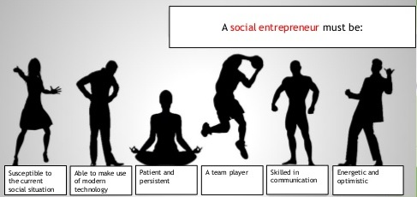
(source: adapted from https://www.slideshare.net/phoenixkm/io4unit-1-what-is-a-social-enterprise)

LEGAL AND OTHER REGULATIONS FOR SOCIAL ENTREPRENURSHIP IN SLOVENIA

Social Entrepreneurship Act
The Social Entrepreneurship Act (ZSocP) (Official Gazette of the Republic of Slovenia, No. 20/2011) (link), was passed in March 2011 and entered into force in January 2012. In the period from the adoption of the act until December 2014, the field of social entrepreneurship was the responsibility of the Ministry of Labor, Family, Social Affairs and Equal Opportunities. From 1 January 2015, it became the responsibility of the Ministry of Economic Development and Technology.
Since the act has entered into force, the need arose to supplement or amend in particular those provisions of the act, which in practice discouraged legal entities from registering to acquire the status of a social enterprise, or made it difficult to maintain that status. For this reason, the Act Amending the Social Entrepreneurship Act (ZSocP-A) (link), (Official Gazette RS, No. 20/11, 90/14 – ZDU-1I and 13/18), which was adopted by the National Assembly of the Republic of Slovenia at its 38th session on 15 February 2018 and entered into force on 15 March 2018.
The key amendments to the Social Entrepreneurship Act are:
1. Elimination of type A and B social enterprises, which have so far differentiated social enterprises according to whether they acquired the status by way of implementation of statutory activities (type A), or whether they acquired the status by way of employing a certain share of hard-to-place unemployed persons (type B).
2. Facilitating the implementation of social entrepreneurship in all areas of economic and non-economic activities, which goes beyond the integration of vulnerable target groups and the provision of social services of general interest, and provides more opportunities for generating social innovation.
As a result of the first two amendments, some administrative obstacles are being eliminated as well: the annual reports to the ministry and the conditions for maintaining status are simplified (it is no longer necessary for social enterprises to report on the number and structure of employees or on the revenue generated from pursuing social entrepreneurship activities).
3. Elimination of restrictions related to social enterprise status registration for legal persons with the status of a sheltered company and/or work centre, because these too are part of social economy.
4. In addition to the above, we are moving closer to European practices that address the broader context of social economy, which includes social entrepreneurship, by making certain concepts clearly defined. This means extending the Social Entrepreneurship Council into the Social Economy Council, and extending the Social Entrepreneurship Development Strategy into the Social Economy Development Strategy.
5. A full (100%) restriction on profit distribution, in order to further emphasize the principle of non-profitability and the fact that the status of social enterprise is truly chosen by those non-profit legal entities whose main activity is the achievement of social impact rather than profit distribution (which, of course, does not mean that they are not market oriented, on the contrary – social enterprises are essentially companies that operate according to market principles and generate revenue in the market).
6. Introducing Social Impact Measurement, which social enterprises will have to publish and report annually to the competent ministry (the Decree on Social Impact Measurement will be adopted by the Government of the Republic of Slovenia within 6 months from the entry into force of ZSocP-A).

Social Economy Development Strategy
On the basis of the Social Entrepreneurship Act 2011, on 25 July 2013, the Government of the Republic of Slovenia adopted the Strategy for the Development of Social Entrepreneurship for the period 2013–2016, which ensured the planned development of social entrepreneurship in the Republic of Slovenia for a period of four years..
In accordance with the Act Amending the Social Entrepreneurship Act – ZSocP-A (Official Gazette of the Republic of Slovenia, No. 13/18), which entered into force on 15 March 2018, the Government had to adopt (by September 2018) the Social Economy Development Strategy as described in the third paragraph of Article 7, for the planning period 2019 to 2029, and the action program referred to in the fourth paragraph of Article 29 for the years 2019 and 2020.
(source: http://www.mgrt.gov.si/si/delovna_podrocja/socialno_podjetnistvo/)

Analysis of the situation in the field of social economy in Slovenia
In February 2018, an Applied Analysis of the Situation (hereinafter: Analysis) in the field of social economy in Slovenia was prepared, which also contains guidelines for the preparation of a long-term Social Economy Development Strategy in Slovenia for 2019-2029, and a short-term action program with an action plan for 2019-2020.
The document provides an explanation of the basic concepts and starting points and characteristics of the social economy. analysis of the social entrepreneurship and social economy sectors in terms of supply and demand, analysis of supporting environments, analysis of market gaps and market opportunities of the social economy sector. High unemployment and the possibility of employing young people and other vulnerable groups, as well as the need for social services such as long-term care services, personal and household services and care services (community care), are highlighted as a key potential for the development of social economy. Another key potential for development is the continuation of privatization, with the possibility of employee buy-outs through cooperatives. The analysis further identifies obstacles and proposes solutions for the transition of the social economy sector from project-based financing to a permanent market activity. The following are pointed out as obstacles: misinterpretation of social entrepreneurship activities (according to internationally accepted definitions, social economies include both, market activities and non-market activities); the false assumption that the marketing activity of social enterprises refers only to sales in the private market, that is, without sales to contracting authorities (the state, municipalities, etc.); and an inadequate understanding of socially beneficial activities performed by social economy entities. The analysis then proposes 5 types of business models for the operation of social economy entities: (1) an absolutely “non-market model”: the social economy entity acts as an operator for the state, which is a contracting authority / payer; (2) a hybrid “non-market / market model” with predominantly non-market activities; (3) a balanced hybrid “market / non-market model”; (4) a hybrid “market / non-market model” with predominantly market activities; and (5) an absolute “market model”.
The last part of the document presents the starting points for the long-term Social Economy Development Strategy and the short-term action program (action plan), with the recommendation that all social economy stakeholders be involved in the strategy's development, and that the content should draw on the conclusions of individual sections from the Applied Analysis of the Situation in the Field of Social Economy in Slovenia. Proposals for strategic and operational objectives are presented: empowered community for and through the development of social economy – a community that connects, participates and is competent in developing a social economy; a functioning social economy ecosystem – an integrated professional civil and national supportive environment for social economy; and the achievement of the planned social economy sector size – employment in the social economy sector 4.1%, and GDP 4.3%. The action program lists regulatory and systemic actions, organizational and promotional actions, and financial mechanisms. Non-repayable financial measures include various calls for tenders, while reverse financial measures include loans and credits. Combined measures and equity financing are also indicated.
(source: http://www.mgrt.gov.si/si/delovna_podrocja/socialno_podjetnistvo/)

Remark: Legal and other regulation on Social Entrepreneurship is represented for Slovenia and it could be different in each EU country.

ESTABLISHING A SOCIAL ENTERPRISE

The status of a social enterprise
The status of a social enterprise can be acquired by a non-profit legal entity, e.g. association, institute, institution, cooperative, European cooperative, employment centre, disability company, corporation, etc., which complies with the principles of social entrepreneurship and the conditions stated in the Social Entrepreneurship Act, and in particular:
• performs economic and non-economic activities,
• does not share assets or excess of income over expenditure,
• is autonomous and organizationally independent in relation to commercial companies, legal entities of public law or local communities,
• ensures an inclusive form of management based on co-decision and democratic decision-making, and
• meets the other conditions laid down in this Act and the law governing the legal organization of each type of non-profit legal entity.
An individual non-profit legal entity that is already established may register as a social enterprise subsequently, or it may do so simultaneously with the time of its establishment with the competent registration authority. The registration authorities and the registration procedure for a social enterprise are defined in the section on the registration procedure. Only a legal entity (of various legal forms) can register a social enterprise, while a natural person (e.g. self-employed entrepreneur, farmer) cannot acquire this status.
(source: http://www.mgrt.gov.si/si/delovna_podrocja/socialno_podjetnistvo/)

When to embark on social entrepreneurship?
Typically, social entrepreneurs engage in areas that are not of interest to traditional entrepreneurs because they do not generate high financial returns. They often also approach areas that could be addressed by the state; however, the state is either unable, incapable or even unwilling to do so. Social entrepreneurs often address environmental issues, fight unemployment, educate in personalized and innovative ways, create affordable tourism products, and promote healthy lifestyles and a local supply of food and other goods.
Ecological / organic farming can be placed in the field of local goods supply and addressing unemployment issues.
In Slovenia, the Act on Social Entrepreneurship precisely defines the activities that a company is allowed to carry out if it functions as a ‘type A’ social enterprise:

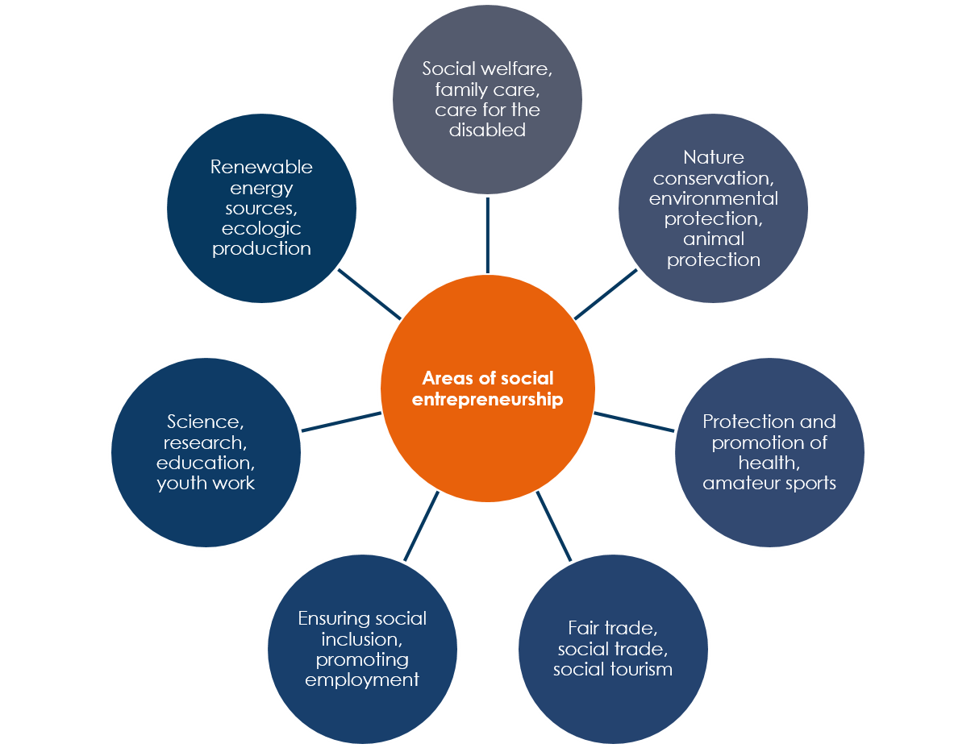

Phases of establishing a social enterprise
- Establishing a non-profit legal entity / non-profit enterprise
- Application for acquiring a social enterprise status
- Application to register an amendment of the instrument of constitution
- Public record registration
The procedure of establishing a non-profit enterprise and acquiring the status of a social enterprise may take place at the same time.
Find out more about the procedure and steps of establishing a social enterprise at:
http://www.invel.si/ostalo/gradiva-podjetnistvo/socialno-podjetnistvo_gradivo.pdf
or at:
http://socialnaekonomija.si/6286-2/
Remark: The procedure of establishing social enterprise is represented for Slovenia and it could be different in each EU country.

Values, mission, vision
Mission, vision and values are the fundamental elements of every organization, including social enterprises. These notions are interpreted very differently in literature, and here is one possible interpretation:
- Values are beliefs about what an organization and its individuals appreciate, what they regard as positive, desirable and worth the effort (e.g., diligence, honesty, ethics, empathy…); something that drives people's behaviour in the organization.
- Mission defines / identifies the purpose of the existence of an organization or company. The mission is usually written in the form of a brief statement, which should cover all those basic concepts that most succinctly describe the organization, its features, services, "products" and "marketplace", core philosophy and goals. (e.g., our mission is to provide healthy, organically produced food at an affordable cost to local people, thereby improving the quality of their health.)
- Vision – in simple terms, a vision is a desire regarding the future of the company, a goal towards which the company is supposed to be striving. It expresses the desired image of the company in the future (e.g., our vision is to become the largest provider of quality local organic food.)
(sources: https://www.ipsos.si/VodenjeVIZ_VI_kaj_je_poslanstvo_vrednote_vizija.html, https://courses.lumenlearning.com/wm-principlesofmanagement/chapter/reading-mission-vision-and-values/)

How to come up with new ideas for social entrepreneurship?
Business ideas in all areas are found everywhere:
- Working environment (former and current workplaces)
- Domestic and international fairs
- Keeping up with trends and changes in the environment (local, international)
- Articles, literature
- Events (seminars, conferences, meetings of various associations and clubs…)
- Research
- Hobbies and other leisure time activities, etc.
You can also find some tips for generating ideas at:
https://www.entrepreneur.com/article/74184
We must be aware that not every business idea is necessarily a good entrepreneurial opportunity. It is necessary to think before realizing the idea and, above all, provide an answer to the question of whether the realization of this idea will guarantee us existence, growth and long-term viability.

Sustainability and development
One of the important principles for the functioning of a social enterprise is investing profits back into the company, so that it can develop and expand. Sustainable development meets the needs of the present without compromising the possibility of future generations to meet their needs.
A great advantage for securing sustainability and development in social entrepreneurship lies precisely in the nature of business – social enterprises address problems of a certain social community, they originate from that community, and grow together with the people from the very beginning. Together with their employees and customers, they plan and build the company, and invest profits back into development – once the customers become aware of the social enterprise's contribution to the environment they live in, they start respecting, rewarding and supporting the company and its work. At some point, the environment will come to realize that the more it helps the social enterprise, the more it really helps itself.
(source: http://www.planbzaslovenijo.si/trajnostni-razvoj)

SOCIAL ENTREPRENURSHIP IN ECOLOGICAL/ORGANIC FARMING

Types of social enterprises – how to choose the suitable type of company in the field of ecological/organic farming
Before setting up a social enterprise, you need to decide on the legal form of your company, prepare the requested specific information, and meet certain conditions. The type of activity you want to perform determines the conditions (e.g., required education, occupational safety courses, HACCP, craft business permit, etc.). The decision about the type of company you want to start is influenced by various factors, such as the type of activity, the extent of individual responsibility, employment opportunities, applying for co-financing sources, etc.
The existing register of social enterprises includes the following types:
- Association
- Foundation (institution)
- Private institute
- Cooperative
- Limited liability company (LLC)
For a more detailed look at the ways of establishing a social enterprise and the specific advantages of particular types, please visit:
https://www.program-podezelja.si/sl/knjiznica/32-podjetniski-prirocnik-z-delovnim-zvezkom-za-socialne-podjetnike-od-ideje-do-socialnega-podjetja-z-druzbenim-ucinkom-avtor-stritar-tomaz/file
An excellent example of a Slovene social enterprise in the field of ecological farming is: Eko kmetija Brinjevka (https://www.brinjevka.si/).
Two similar companies are Korenika (https://www.korenika.si/) and the cooperative Zemlja-morje (https://www.zemljainmorje.si/).
Examples of international eco-farming social enterprises: https://socialenterprise.org.hk/en/sedb/cats/se-business-organic-farm

THE ROLE OF STAKEHOLDERS AND NETWORKING IN THE SUCCESS OF A SOCIAL ENTERPRISE

Who are the stakeholders?
The stakeholders of a social enterprise are all those individuals, organizations or groups of people who are relevant to the enterprise – both those who are directly affected by the operation of the company and those who can affect the business through their activities.
It is important for a social entrepreneur to identify the potential external and internal stakeholders of their business:

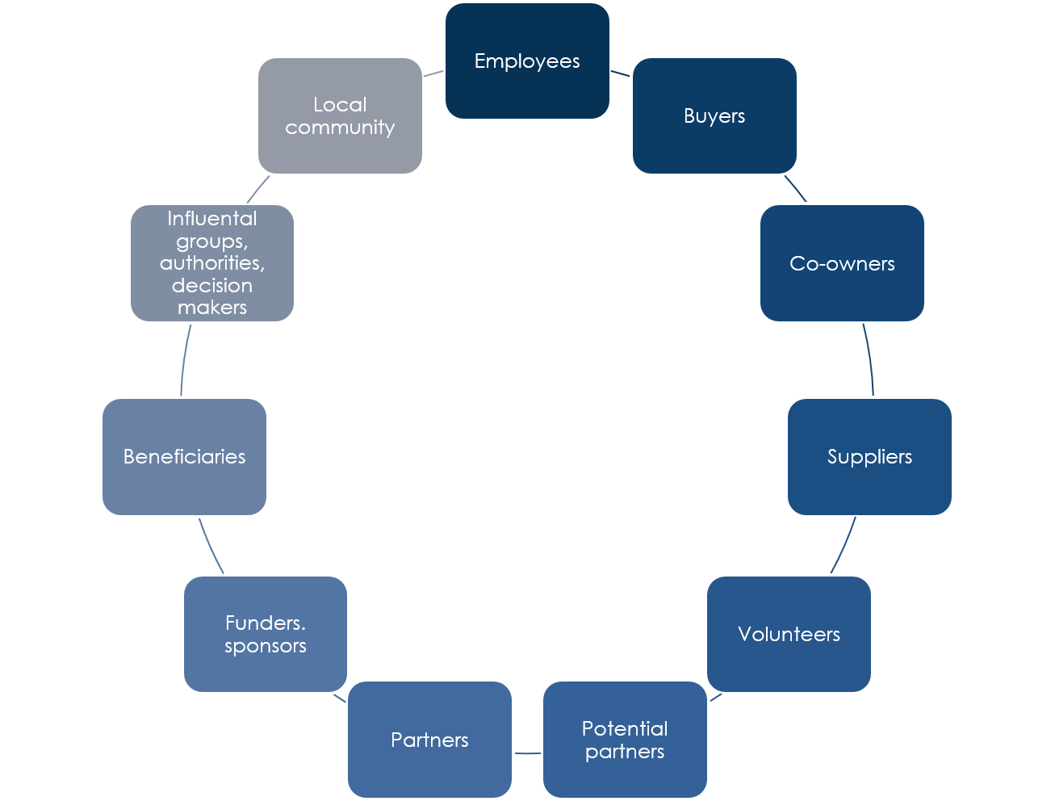
SOCIAL
ENTERPRISE

In the “business life cycle”, the entrepreneur interacts with different stakeholders - individuals / groups / institutions. Some of those who are not yet stakeholders of the company at the start-up stage may become crucial in the later stages of creating a “successful social entrepreneurship story”.
Why is it important for an entrepreneur to recognize the company's stakeholders?
  - To understand the impact of your business on different audiences.
  - To allow stakeholders (when and if necessary) to express their opinions and influence the operation of the business.
  - To increase community awareness and responsiveness to specific problems.
  - To establish suitable ways of communication with individual stakeholder groups.
Just like considering how the performance of the company will affect different stakeholder groups, the entrepreneur should also consider how the stakeholders could affect the performance of the business. With their feedback, opinions, suggestions, support, etc., they can make a significant contribution to the success and sustainable development of a social enterprise.
Different stakeholders have different roles in the business of the company, different levels of involvement and, of course, different interests. The entrepreneur must be careful that the interests of different stakeholders are not in conflict, which can affect the business of the company.
Undoubtedly, the most important stakeholders of any business are the customers, who purchase services / products for themselves or for others. Loyal returning customers provide the company with long-term stability and development. If the company does not meet their expectations and does not meet their needs, they will not support the business with repeated purchases and will not recommend purchases to other buyers. The key to long-term success is establishing a relationship with customers and ensuring that the customer receives the desired value for their money.
Another important group is beneficiaries. How do we distinguish customers from beneficiaries? Beneficiaries are a group that directly uses and benefits from the products / services. It is important for a social enterprise to consider this important stakeholder group when planning and implementing their activity. This is the group for which the social enterprise service / product is actually intended, the reason why the company exists in the first place, and even acquires funding / donations.
The third important group are the decision-makers / influencers. They influence the awareness and opinion of the customers and thereby their buying habits. It is important that we appropriately position a social enterprise within this group and build a successful business through their support. We need to be aware that our customers and beneficiaries can become influencers over time, and that their recommendations of the company to the general public can influence the success of our operations. When an influencer recommends a purchase in our company, this “lowers the risk” for a potential buyer, who makes the decision to purchase more easily. And a positive experience leads to repeating the purchase.
(source: https://www.youtube.com/watch?v=WjxvP5eitzk)

Networking

Strong business connections often prove to be crucial for the success of a business. The same goes for social entrepreneurship. There are many international conferences held abroad, which network exclusively with social entrepreneurs. You can also build strong relationships through volunteer work with social, non-profit organizations, and perhaps gain education in return for your help.
For a social entrepreneur, it is important to have a wide network of diverse contacts (individuals, institutions, groups, etc.) that can help him or her succeed in the business. Networking is a continuous process. An entrepreneur does not create new contacts only when needing them, but should always be “on the alert” to establish new contacts and relationships.
A very convenient way to network is to attend various events (conferences, stakeholder meetings, etc.). Choose your events wisely - most often, event organizers announce in advance who will be present at the event, so you can quickly assess whether you will be able to develop new quality business contacts that will later contribute to the viability of your business.
You need to be aware that not all networking efforts will result in an immediate impact on your business.
Social networks are another great opportunity for networking; they allow you to very easily get in touch with the person / group you are interested in. Even a short, but carefully designed message, can help you create quality contacts without any kind of financial input.
(source: https://mladipodjetnik.si/novice-in-dogodki/novice/nasvet-iz-prve-roke-kako-se-mreziti)

LEAN BUSINESS PLAN

About the lean business plan
Before we start considering social entrepreneurship, we need to have a good idea. Any idea that solves a problem is a good idea. An idea that solves a specific problem of people is called a business idea. To have just an idea, however, is (usually) not enough: a plan of how the business is going to operate must also be developed. Such a plan is called a business plan. If we want our company to function, we need to prepare a functioning business plan. In the past, writing business plans used to be a quite complicated and often tedious task, whereas today, business plans can be drawn up on a single page. Such a business plan is called a lean business plan, or sometimes a lean canvas (shown in the table below). Achieving such a plan is simpler.

PROBLEMS  1 | SOLUTION  4 | UNIQUE VALUE PROPOSITION  3 |  | SOCIAL IMPACT  9 | TARGET CUSTOMERS  2
PROBLEMS  1 | KEY PERFORMANCE INDICATORS  8 |  |  | PATHS TO CUSTOMERS  5 | TARGET CUSTOMERS  2
COST STRUCTURE  7 |  |  | REVENUE STREAMS  6

Note: The lean canvas is based on the business model canvas (www.businessmodelgeneration.com), and is licensed under the Creative Commons Attribution - Share Alike 3.0 Un-ported License.
(source: https://www.famnit.upr.si/sl/resources/files/novice/prirocnikpopri.pdf)
Find out all about lean business plans and how to realize them here: https://ecofar.fnm.um.si/course/view.php?id=3#section-2
The web site https://ecofar.fnm.um.si/mod/page/view.php?id=24 will also provide an online tool for filling out a lean business plan, which you can access by means of a user name and password.
For international participants the explanation of lean business canvas is explained at: https://bmtoolbox.net/tools/lean-canvas/

Questions for knowledge assessment

- What is social entrepreneurship? (description of definition)

- Describe the difference between a social enterprise and a socially responsible company.

- List three areas in which social entrepreneurship is most commonly established.

- What is the fundamental difference between social entrepreneurship and commercial/marketing entrepreneurship?

- What challenges can be addresses by means of social entrepreneurship? Circle the correct answer.
- A million people are living below the poverty line
- Millions of children die due to diseases that could be prevented by vaccination
- Low level of school inclusion for girls
- Climate change
- All of the above
6. Social innovation originates from individuals, groups and organizations and can be realized:
- In the commercial sector only
- Only in the non-profit / social entrepreneurship sector
- In the public sector only
- In all the sectors listed
7. What is the most important element in pursuing social innovation?
- Development of a financial model
- Understanding all obstacles to success
- Identification of social change / problem
- Designing, evaluating and developing constructive solutions
8. Which of the following best describes a "social entrepreneur"?
- A person with a charismatic personality
- Someone who has developed an innovative solution to a social problem
- An entrepreneur who depends on social media such as Facebook, Twitter… and advertises his/her products in these media
- Entrepreneur working with a range of business partners

9. What law defines social entrepreneurship in your country and in what way?
10. How does the legislation in your country define the acquisition of a social enterprise status?
11. What are the most important traits and competencies of a successful "social entrepreneur"?
12. If you were the owner and manager of a social enterprise, you would:
• work pro bono (free of charge).
• work pro bono and demanded the same from your employees.
• have the ability to earn and pay salaries to your employees.

13. Can social entrepreneurship ideas be implemented through public-private partnerships? Justify your answer.
- Yes
- No

14. Briefly describe three approaches to generating social entrepreneurial ideas.
15. Is an entrepreneurial idea the same as an entrepreneurial opportunity? Justify your answer.
- Yes
- No

16. Describe the process of identifying an entrepreneurial opportunity!
17. Explain what a company vision is.
18. Explain what the mission of a company is.
19. Explain what the values of a company are.
20. Explain the “lean business plan” model.
21. Why do we use SWOT analysis (Strengths - Weaknesses - Opportunities - Threats)?
22. What are the steps in launching a social business?
23. List three possible forms of social enterprise.
24. List five groups of potential stakeholders of a social enterprise.
25. What is the role of networking in social entrepreneurship?
26. Draw a lean business plan scheme!

Interesting additional sources

Sources in SIovene language:
http://www.invel.si/ostalo/gradiva-podjetnistvo/socialno-podjetnistvo_gradivo.pdf
https://www.program-podezelja.si/sl/knjiznica/32-podjetniski-prirocnik-z-delovnim-zvezkom-za-socialne-podjetnike-od-ideje-do-socialnega-podjetja-z-druzbenim-ucinkom-avtor-stritar-tomaz/file
http://www.socialni-inovatorji.si/
https://sredisce-rotunda.si/wp-content/uploads/2013/08/Delavnica1_Osnove_socialnega_podjetnistva.pdf

Sources in English language:
https://www.ris-dr.si/data/attachment/f673929b7ae05128dd473c556386a7b585483947/1532415653MY_IDEA_MY_FUTURE_first_steps_to_social_entrepreneurship.pdf
https://www.socialsmeacademy.eu/wp-content/uploads/2019/04/SSMEA-Manual_EN.pdf
http://www.animaweb.org/sites/default/files/emi-social-entrepreneurship-guide.pdf
https://gea-college.si/wp-content/uploads/2016/06/IDEANNOVASHIP-O1-methodology-final-2016-Dec-rev-IBOX.pdf
http://www.inclufar.eu/wp-content/uploads/8.1-English-Version.pdf

